Creation Of Table In Power BI

Table 1 : Sustainability Supply Chain Performance Table

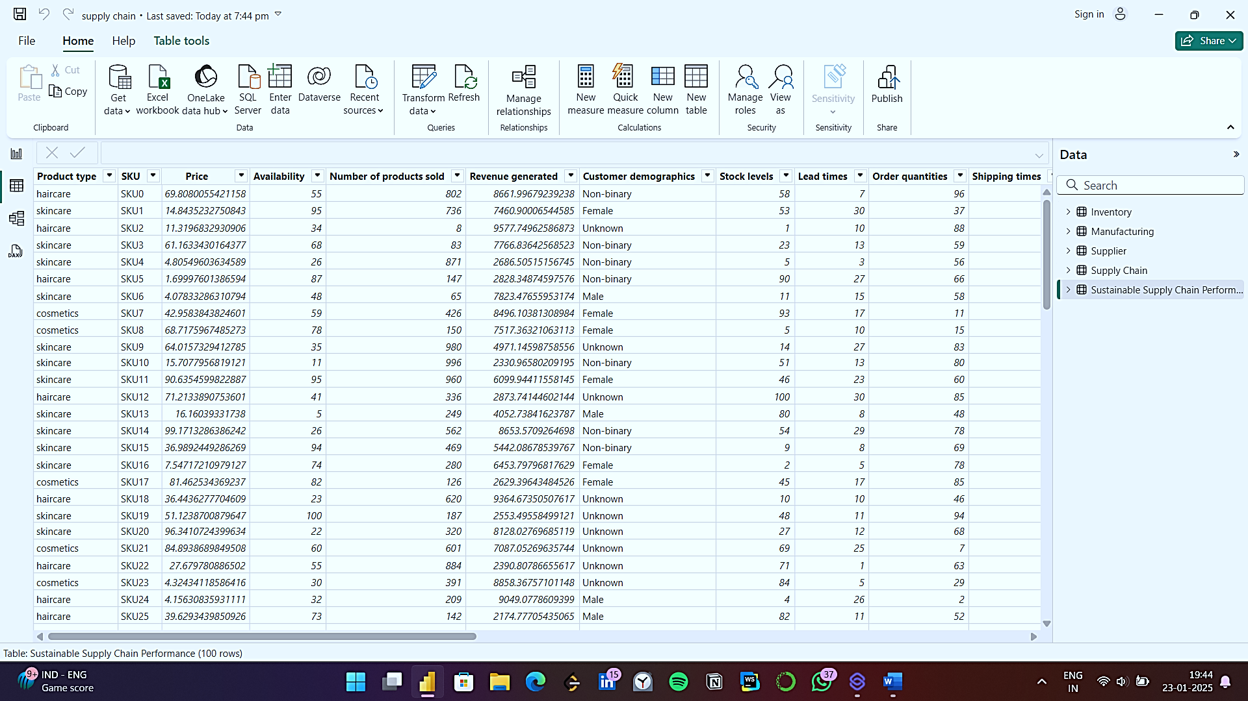

This is the given table and from this table we need to remove the unnecessary information from this table

Table 2: Inventory Table

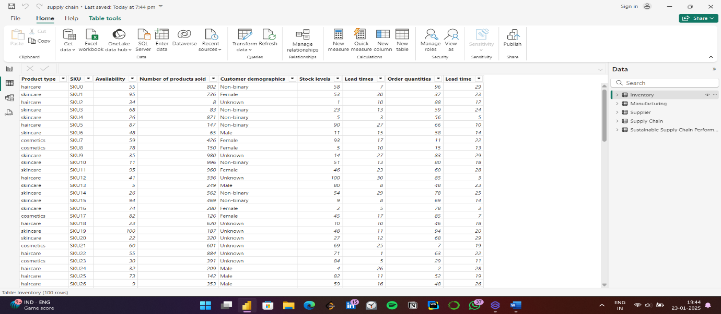

In the inventory table we need to include following columns:

1. Product Type
2. SKU
3. Availability
4. Number of products sold
5. Customer Demographics
6. Stock levels
7. Lead times
8. Order quantites
9. Lead time

Table 3: Manufacturing

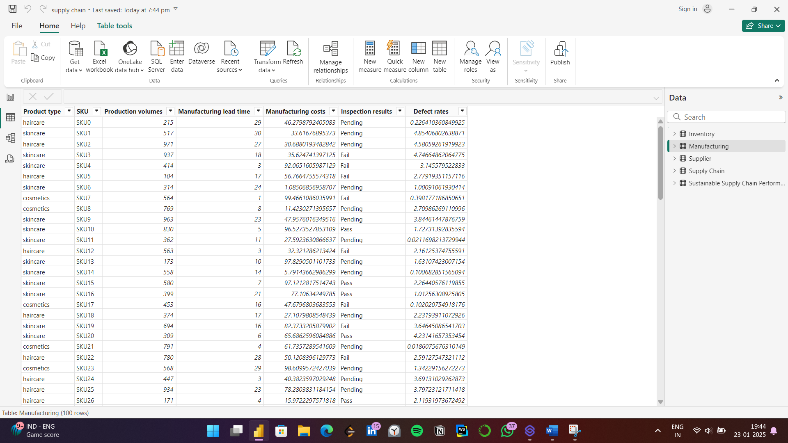

In manufacturing table we need to include

1. Product type
2. SKU
3. Production Values
4. Manufacturing lead time
5. Manufacturing costs
6. Inspection results
7. Defect rates

Table 4: Supplier

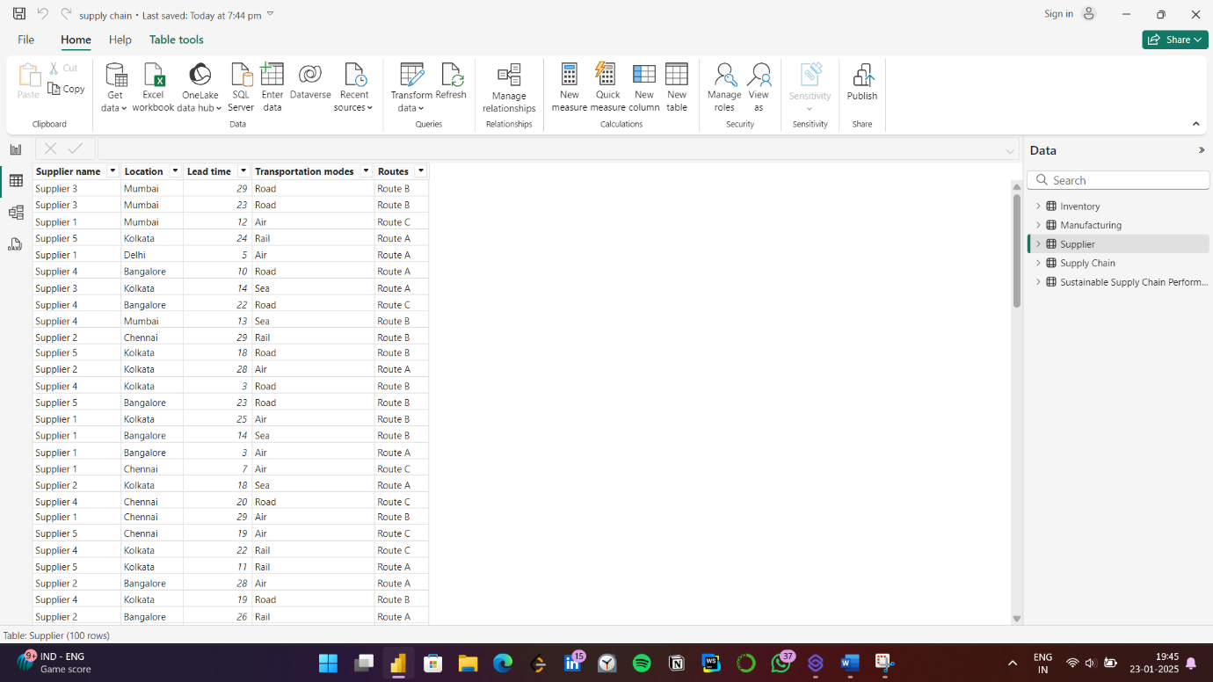Supplier contain columns of:

1. Supplier name
2. Location
3. Lead time
4. Transportation modes
5. Routes

Table 5 : Supply Chain

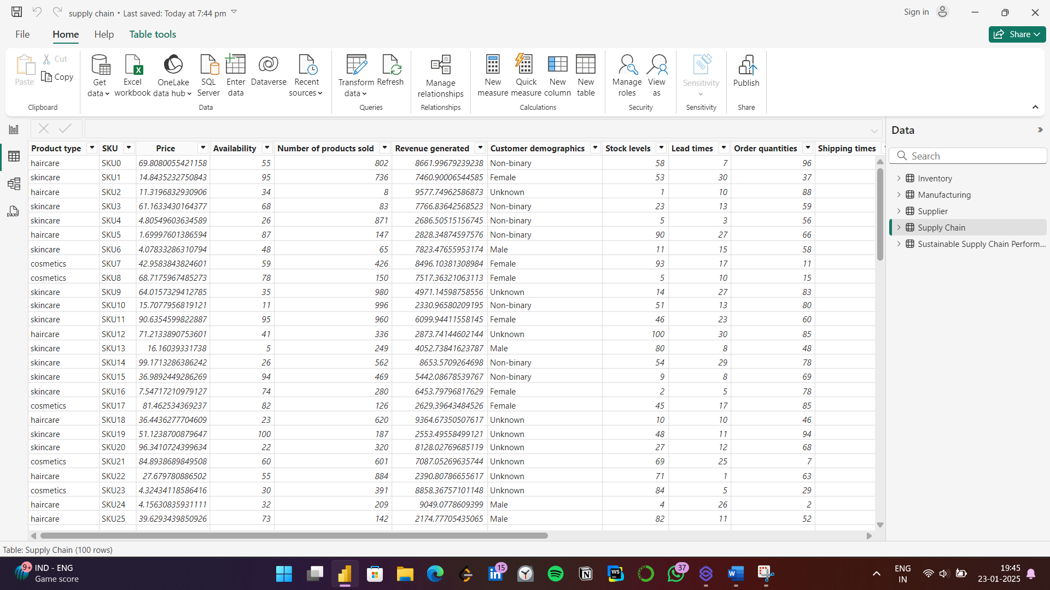

The supply chain contains columns of:

1. Product type
2. SKU
3. Price
4. Availability
5. Number of products sold
6. Revenue generated
7. Customer demographics
8. Stock levels
9. Lead times
10. Order quantites
11. Shipping times
12. Shipping carries
13. Shipping costs
14. Supplier name
15. Location
16. Lead time
17. Transportation modes
18. Routes

Table structure

